MySQL Joins:

inner join(join): will return only the rows that have matching values in both table.

left join:will returns all records from the left table and matching records from the right table.

right join: will returns all records from the right table and matching records from the left table.

full join: will returns all records from both tables. (Using union)

cross join: will returns all possible combinations of rows from both tables.

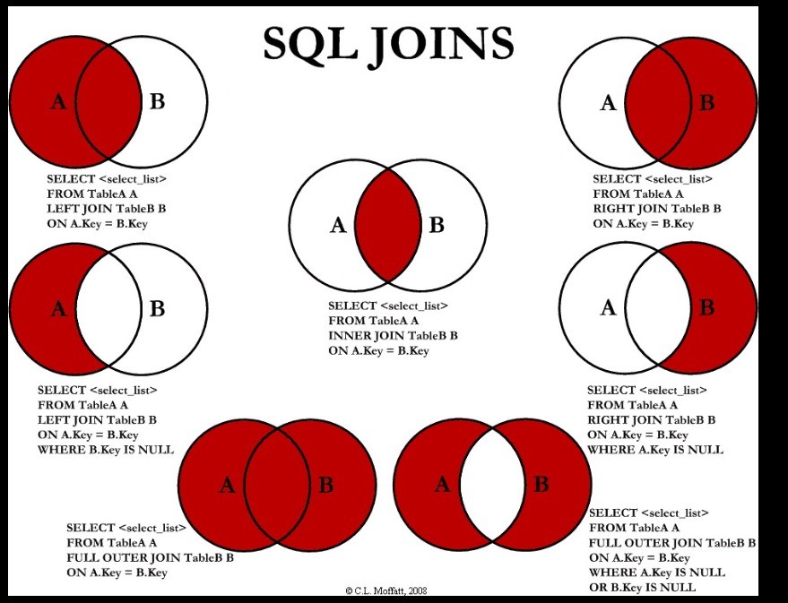
MySQL Joins:

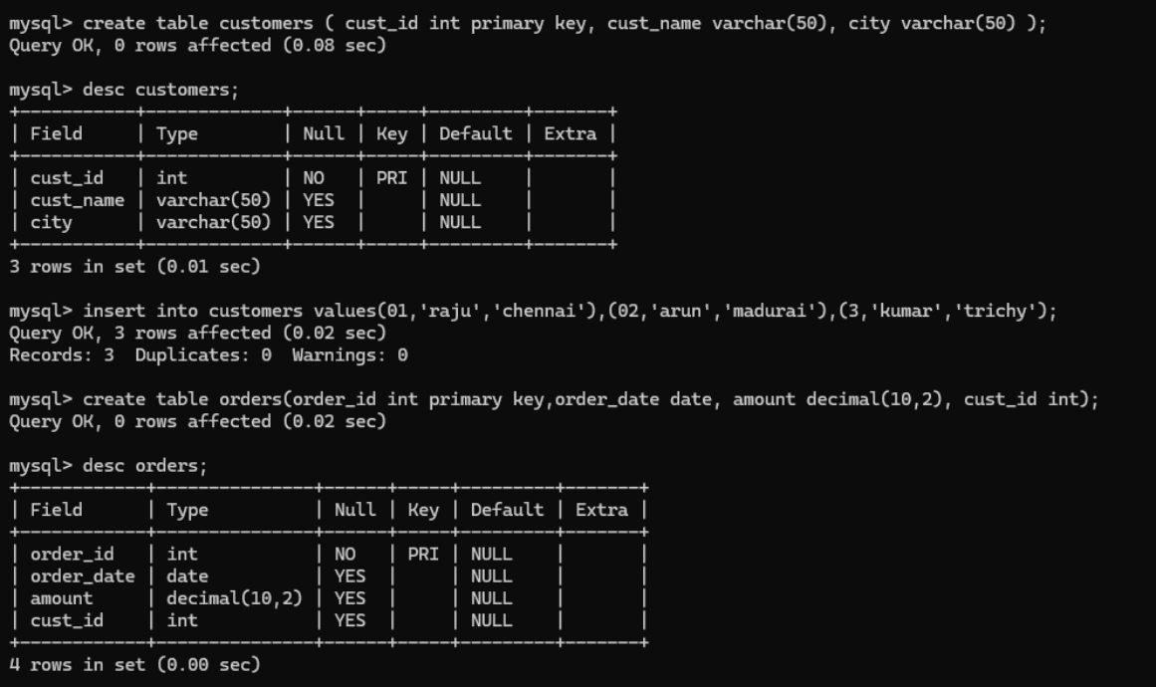

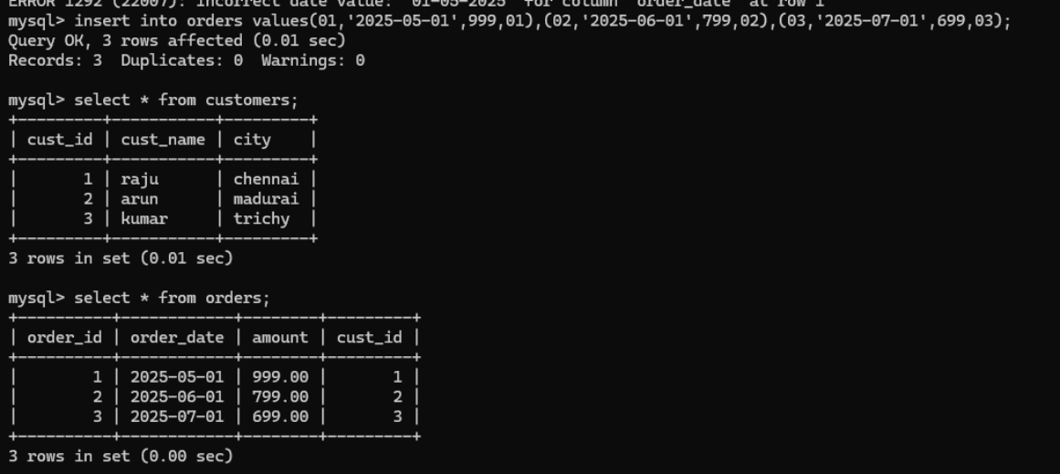
Inner Join:

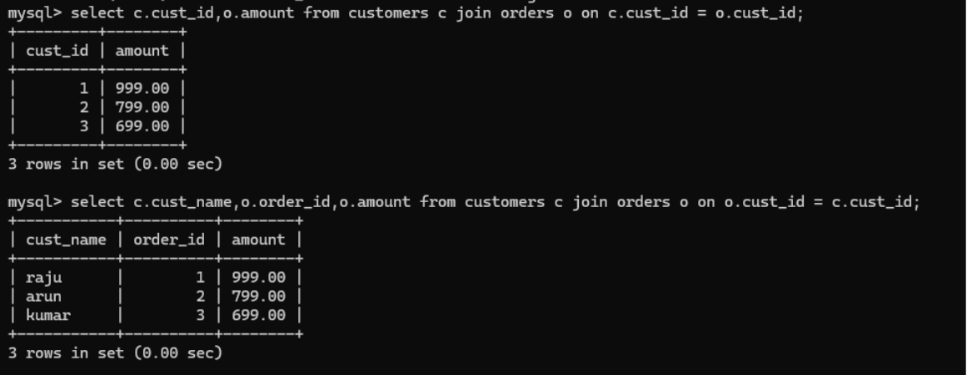
Left Join:

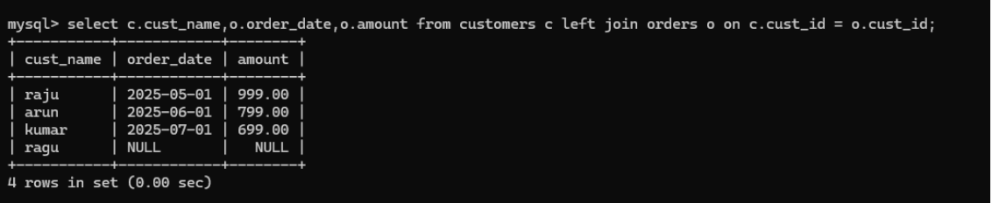
Right Join:

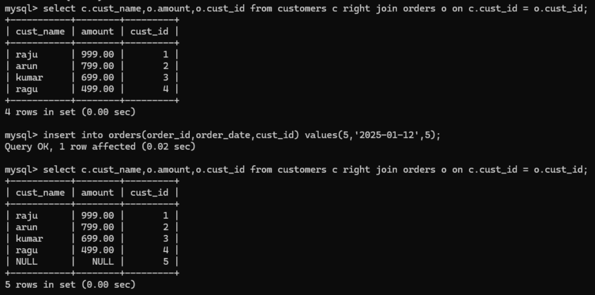

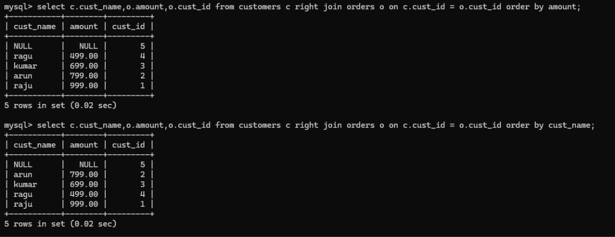
Right join with order and limit.

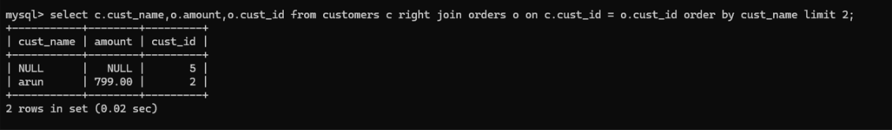
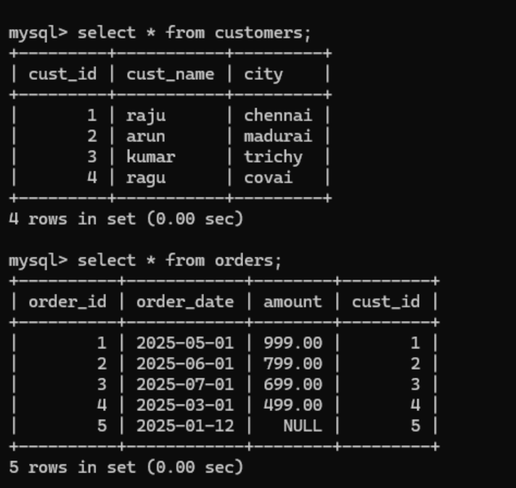

Full Join using UNION:

select c.cust_id,o.order_id from customers c left join orders o on c.cust_id = o.cust_id union select c.cust_id,o.order_id from customers c right join orders o
on c.cust_id = o.cust_id;

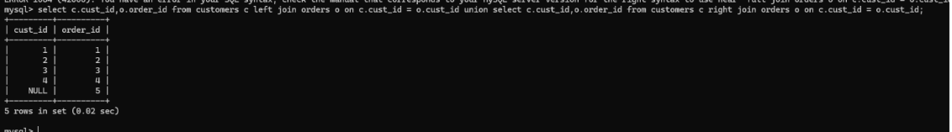
Cross Join:

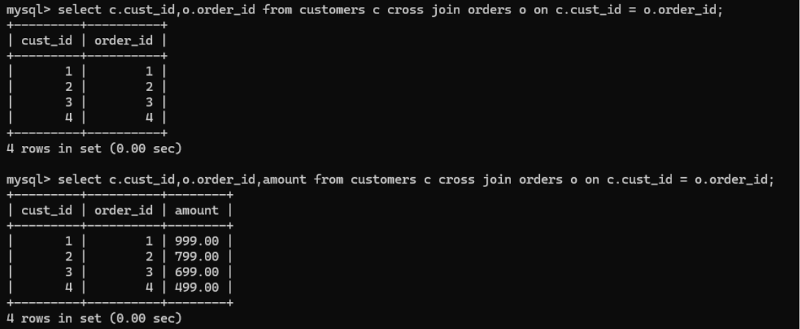
Cross Join:
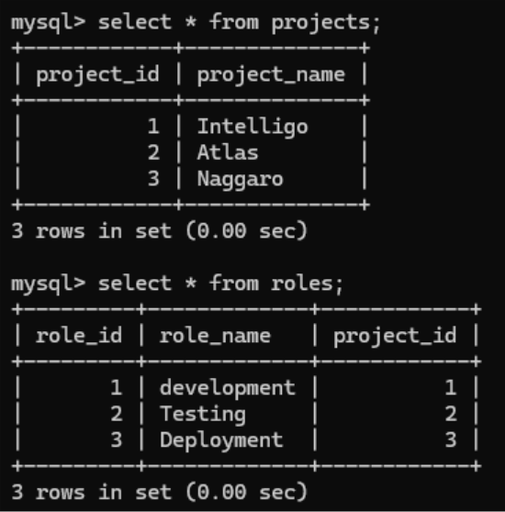

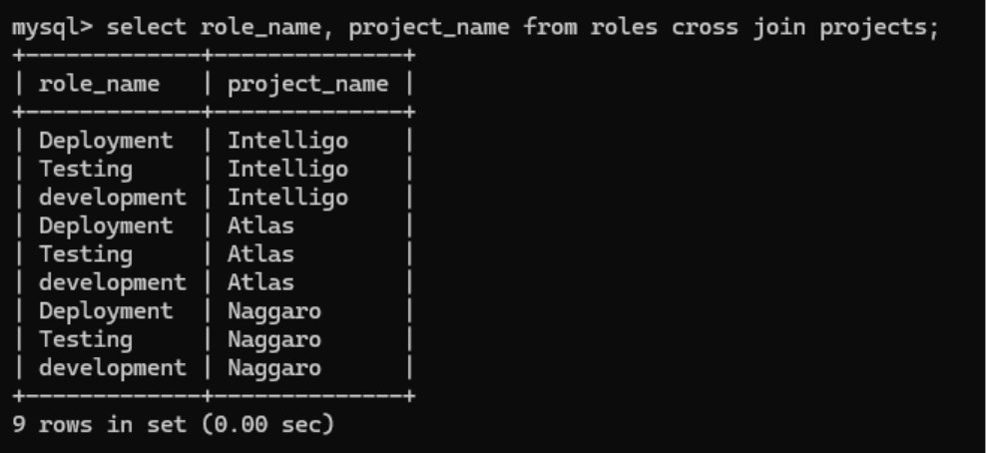
How to save joins output:
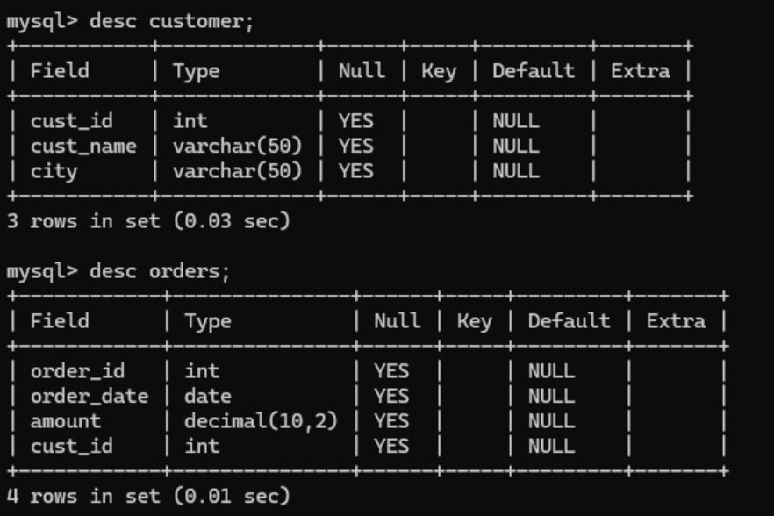

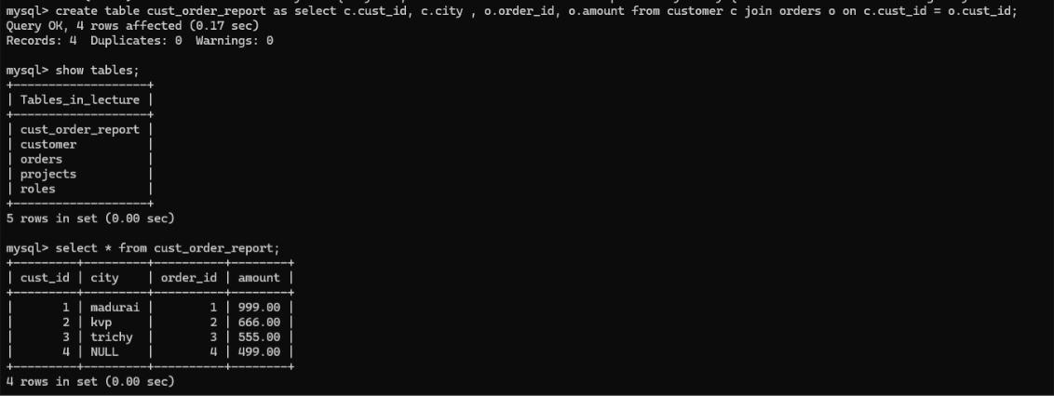
Left anti join:
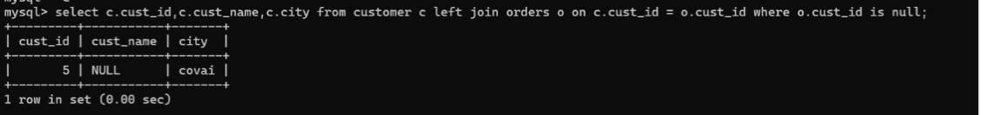
Right anti join:

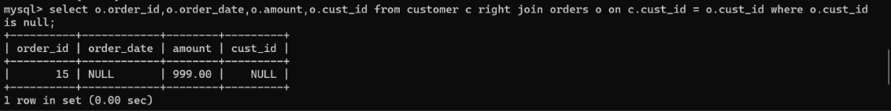

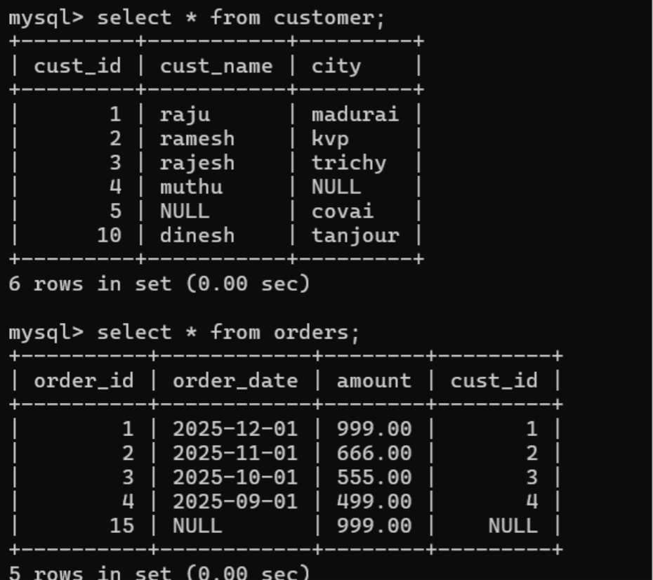
Full anti join using union:

